Arts and Craft Workshops with Open Arts

Pre-booking is required to stop you having to queue for long times.
Our Arts and Craft workshops will be 50 minutes each and are scheduled at 11am, 12pm, and 1pm each day. They will be located in the workshop tent.
There will be step-free access to the tent. Event Assistants will be on hand to help those who may need it, they will be wearing blue hi-visibility vests that look like this:

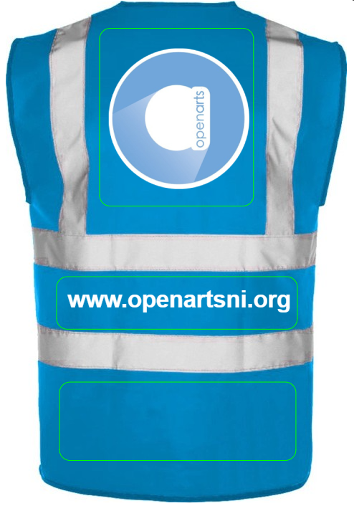
It may get messy as you will be using water-based paint for printmaking. Aprons will be available and there will be basins of water and wipes to clean your hands.

You will meet our facilitators Richard, Sheelagh and AnneMarie, they look like this:
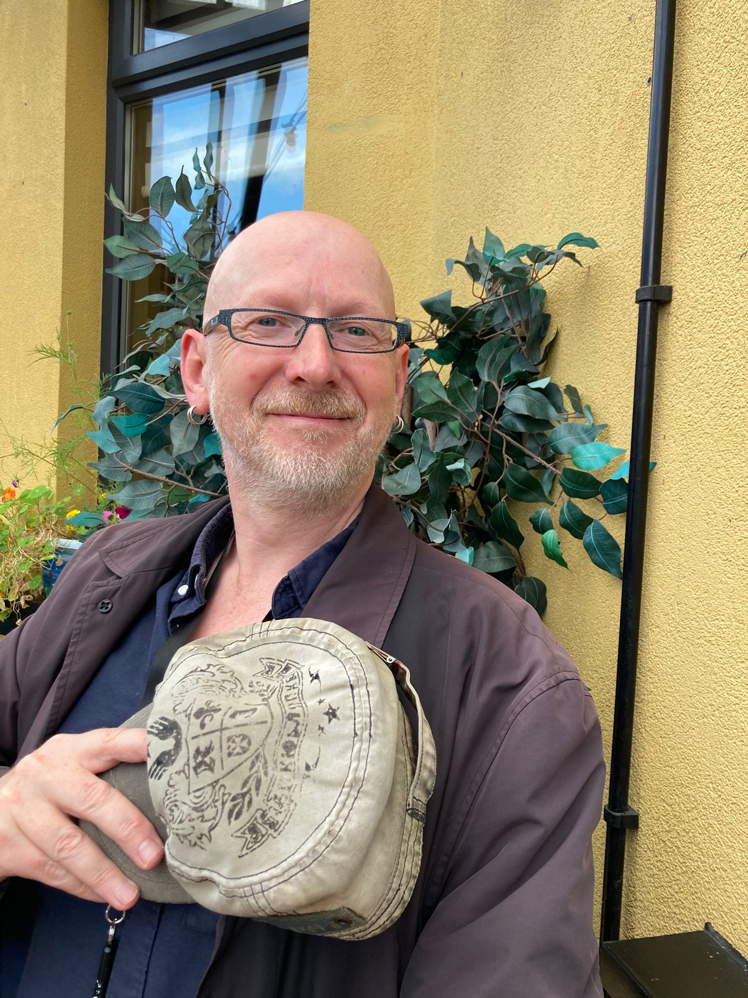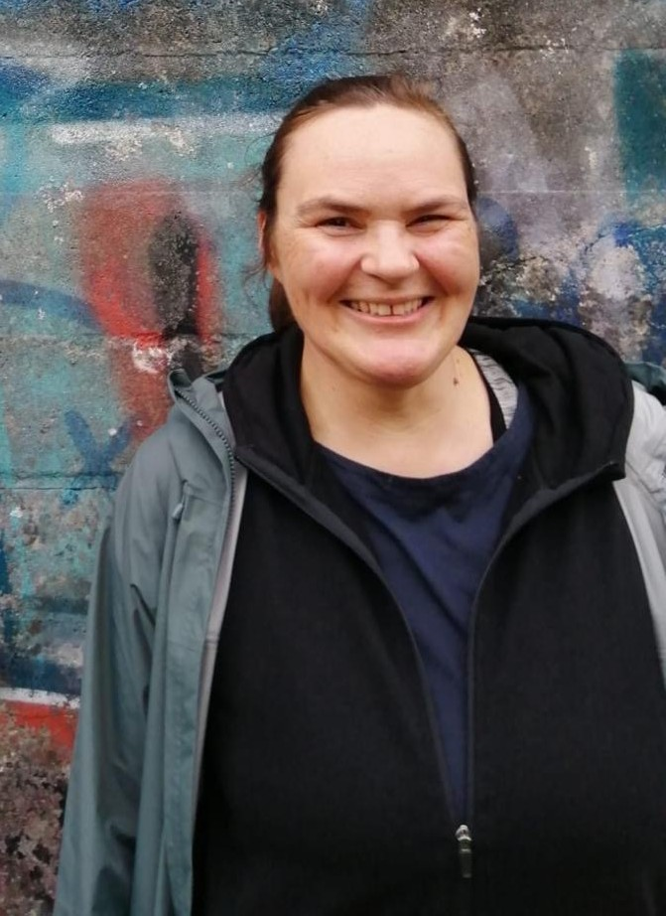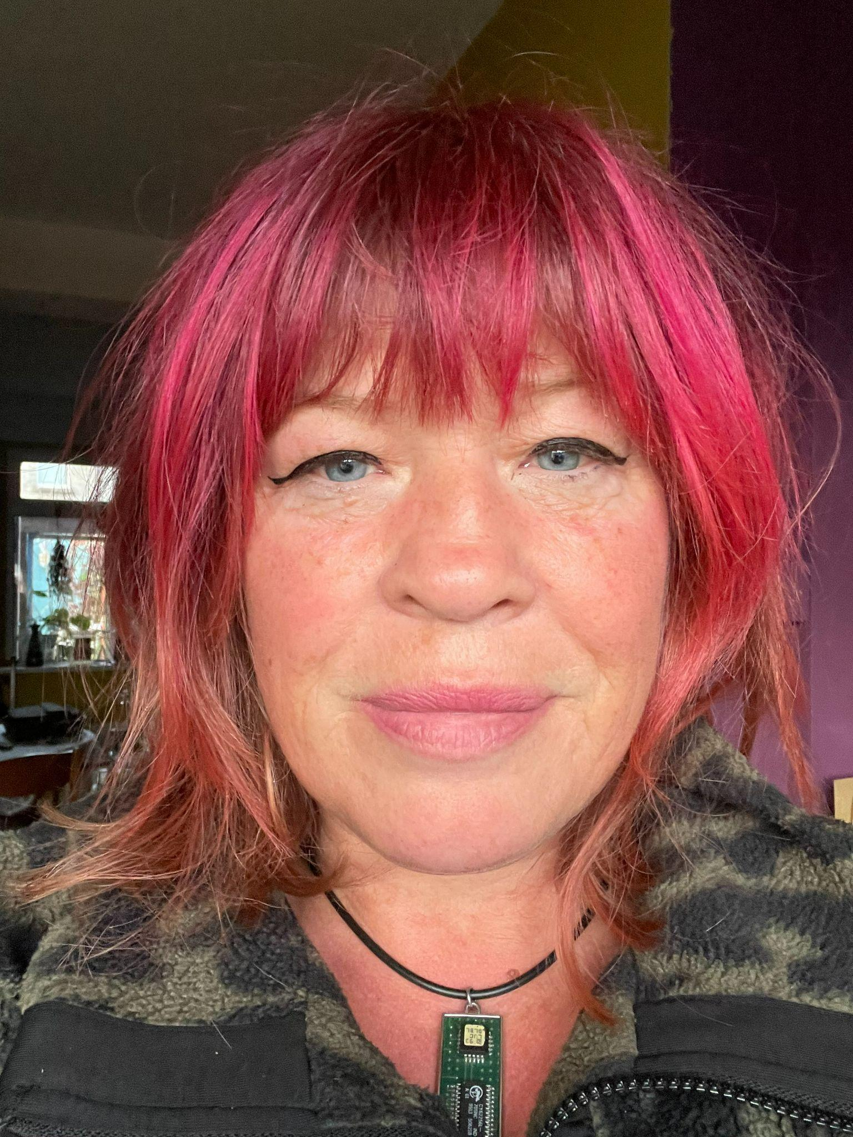
Richard Sheelagh AnneMarie

The tent will be a nut free area so you will see signs like this:


