City Sensations Access Guide

Accessibility Overview
- Dedicated car park for those with a blue badge and/or a workshop ticket.
- Level ground with ramp access throughout.
- Mobile Changing Place on site & other toilet provisions.
- BSL interpreter on site all day.
- Staff trained in audio description & sighted guiding.
- Staff will have communication cards on their person for alternative communication needs.
- Programme information available in braille.
- Sensory space available all day.
- Ear defenders and sensory support items available from the Here to Help point.
- Event Assistants available in blue high-visability shirts.
- Dedicated mobile number for call, messages, voicenotes.
- All marquees and tents will be nut-free zones.
- Water available for guide dogs.

Before You Visit Guide
You are going to the City Sensations in the City Quays Gardens. Below are the activities you may see:
- Arts and Craft Workshops with Open Arts
- Inclusive Dance Workshops with Talia McDowell Dance
- Takeaway Theatre
- Songs and Gongs with Open Arts
- Inclusive Circus Workshops with Streetwise Community Circus
- Live musical performances
- DJ set & music
- Audio Described Tours
- Sensory Space

All workshops and some activities are pre-booked so that you do not have to queue for long times.

Getting there
There are lots of ways that you can get to the City Quay Gardens.

By Bus
From the City Centre you can get the G2, 6a, 3a, 4c/d/e 5a or 5a buses to Custom House Square/Queens Square then cross the road to The Big Fish (Salmon of Knowledge). From there it is an 8-minute walk or wheel to the garden along Donegall Quay. You may see some performers along the quay.
The bus may look like this:
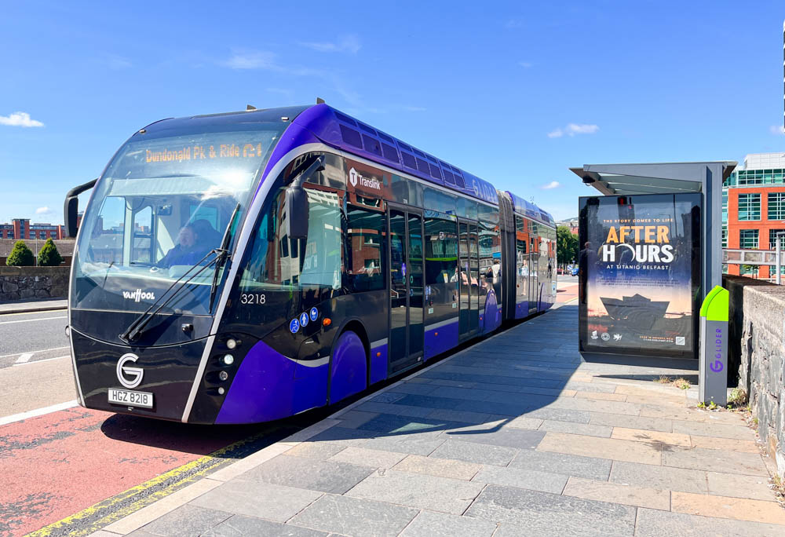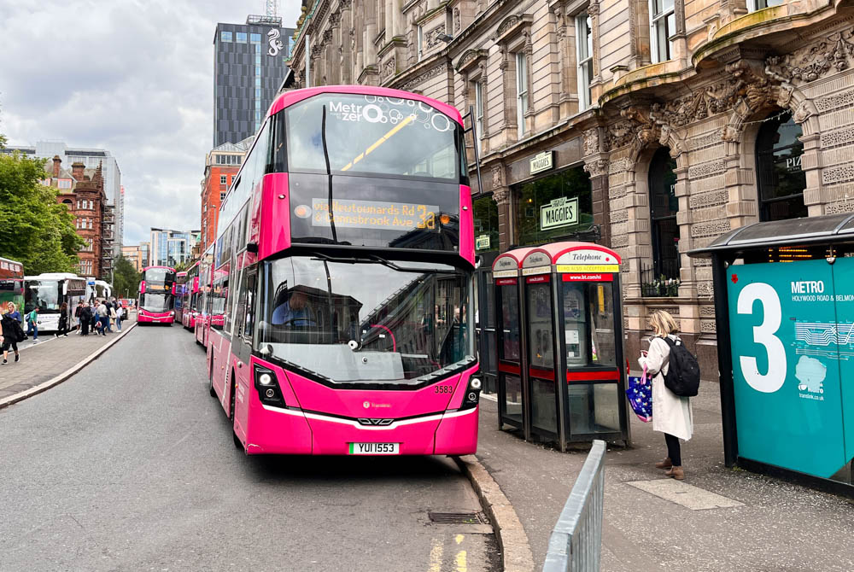

By Taxi
You can get a taxi to the City Quay Gardens; they should drop you off beside the entrance or at designated spaces across the road. You can hire black taxis which are in taxi ranks around Belfast. Local taxi companies that you can book via app, phone call or online include Fonacab and ValueCab.

The taxi may look like this:
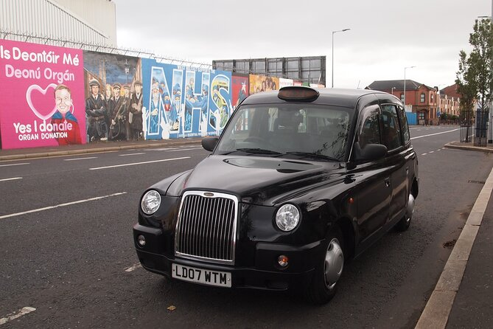

By Car
You will drive to Corporation Square to get to City Quays Garden. There is a dedicated carpark for blue badge holders and people with workshop confirmations, which is very close to the garden and will be first come, first served. It is located beside the AC Marriott Hotel, Donegal Quay. This is what our car park looks like:
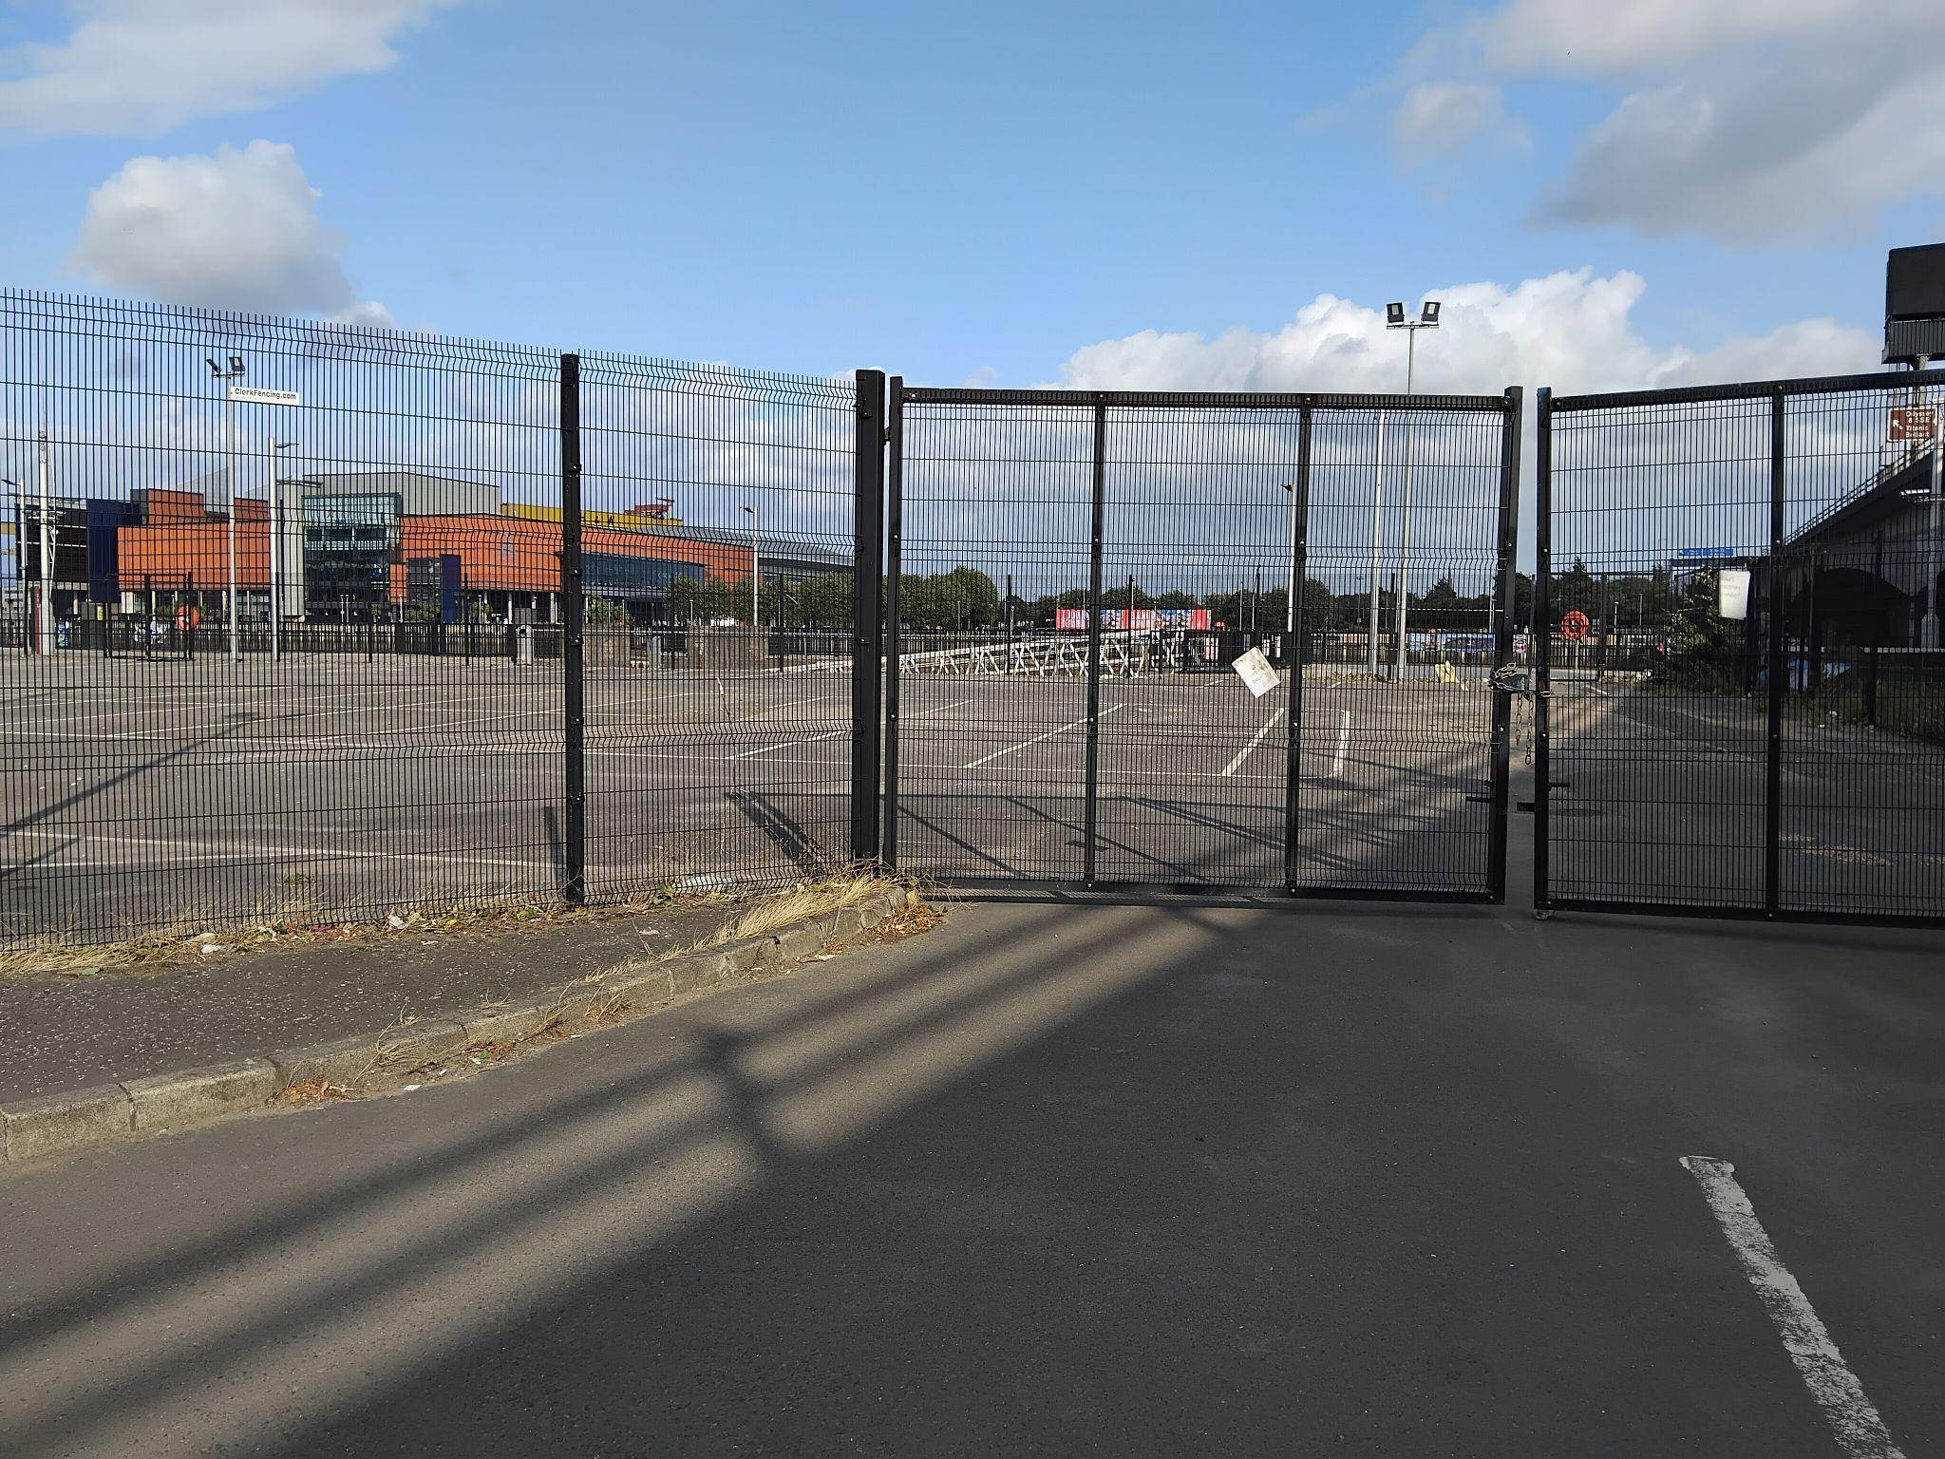

Inside City Quay Gardens
Our entrance to the gardens is located beside the Harbour Commissioners Building and looks like this:

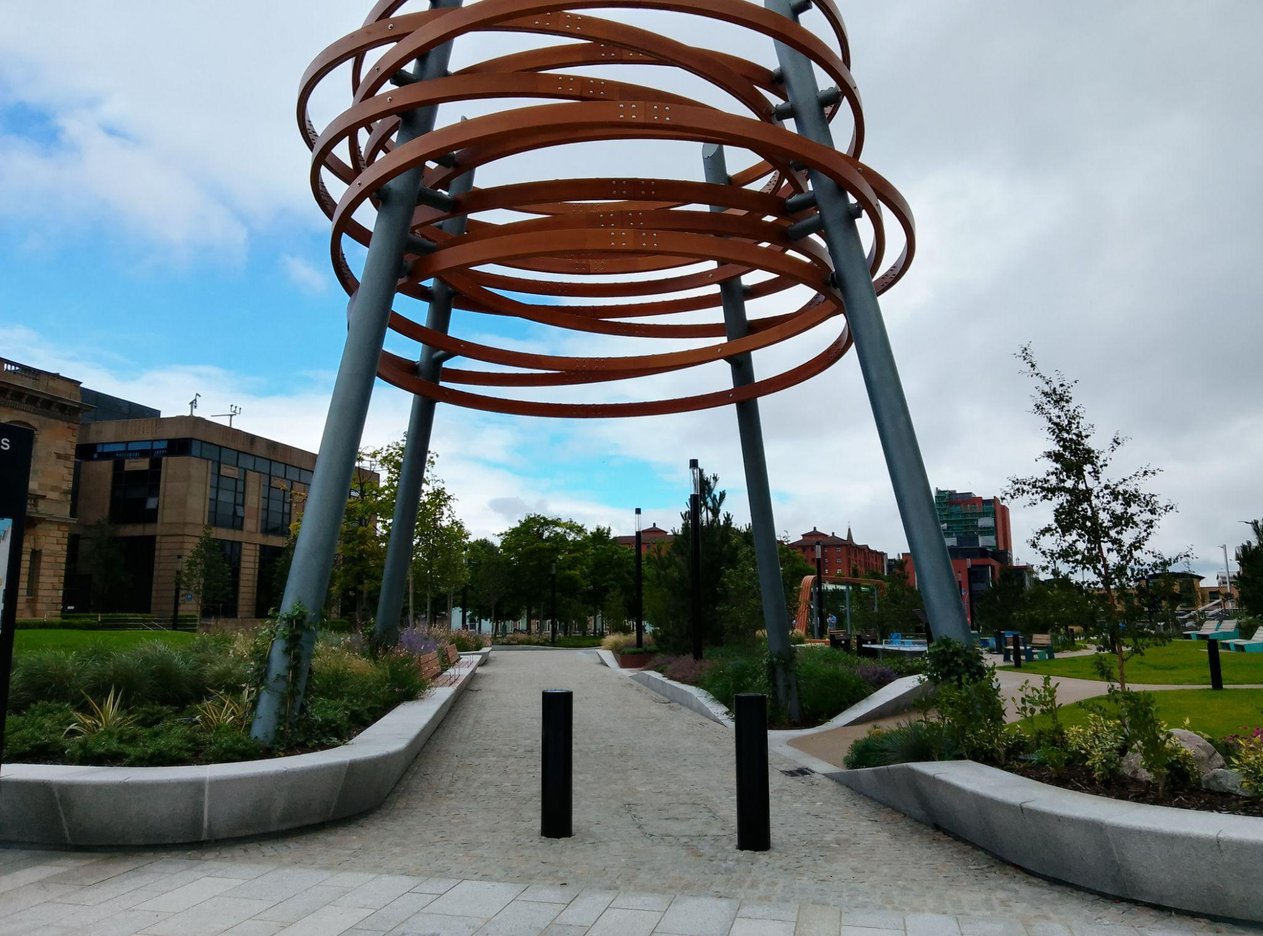

Getting around is generally smooth, though there are cobbled areas to be aware of. Our friendly Event Assistants will be happy to guide you. There will be ramps for access onto the main activity lawns and into tents.

When you enter the gardens, it may be loud as you enter into the Festival Space but we will have signs like this to let you know.
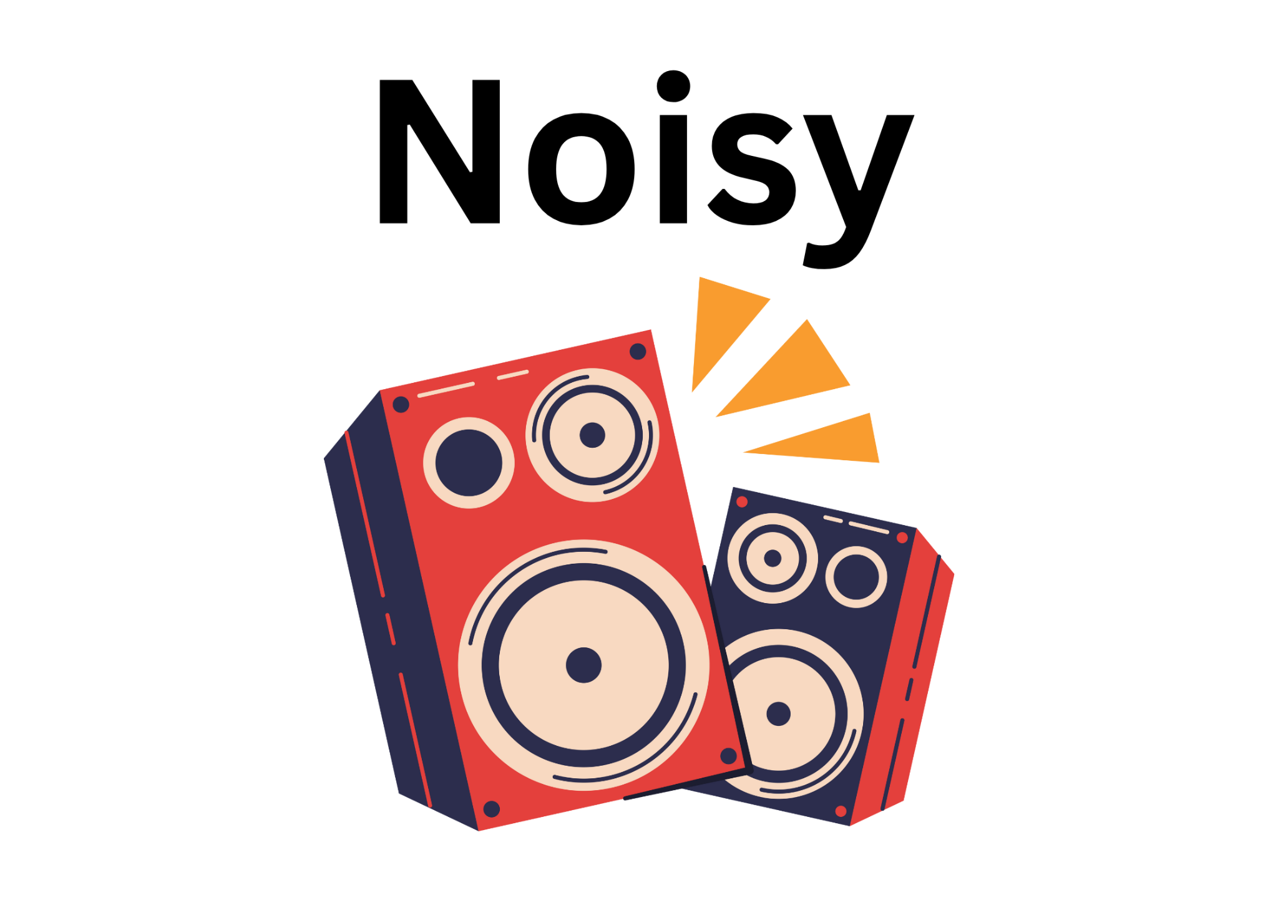

There will be large games such as Connect 4 and Snakes and Ladders, as well as speakers playing live music or DJs. If you are struggling with the noise, you can move to the back of the garden into a more quiet and relaxed space or alert a member of staff for help. Ear defenders and plugs are available for children and adults if needed from the Here to Help desk.

Here to Help Desk
Our Here to Help Desk will have signs on it that look like this:


It might be busy, with lots of people around. If you are overwhelmed or need extra help for any reason, there will be an Event Assistant at our Here to Help desk at all times. There will also be a BSL Interpreter who can be contacted from the Here to Help Desk. It will be located near the entrance to the garden. Our Event Assistants will be happy to help you with whatever you need. Our Event Assistants will be wearing blue high-visibility with Open Arts logos. It will look like this:
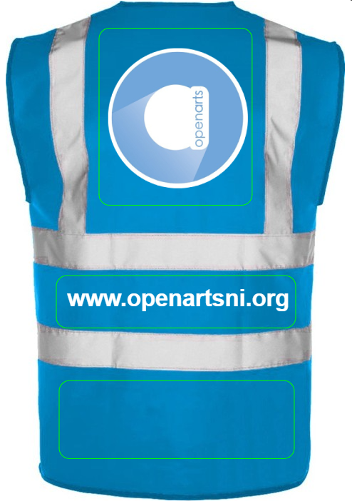

All Event Assistants will be carrying communication cards for those who may require alternative communication.
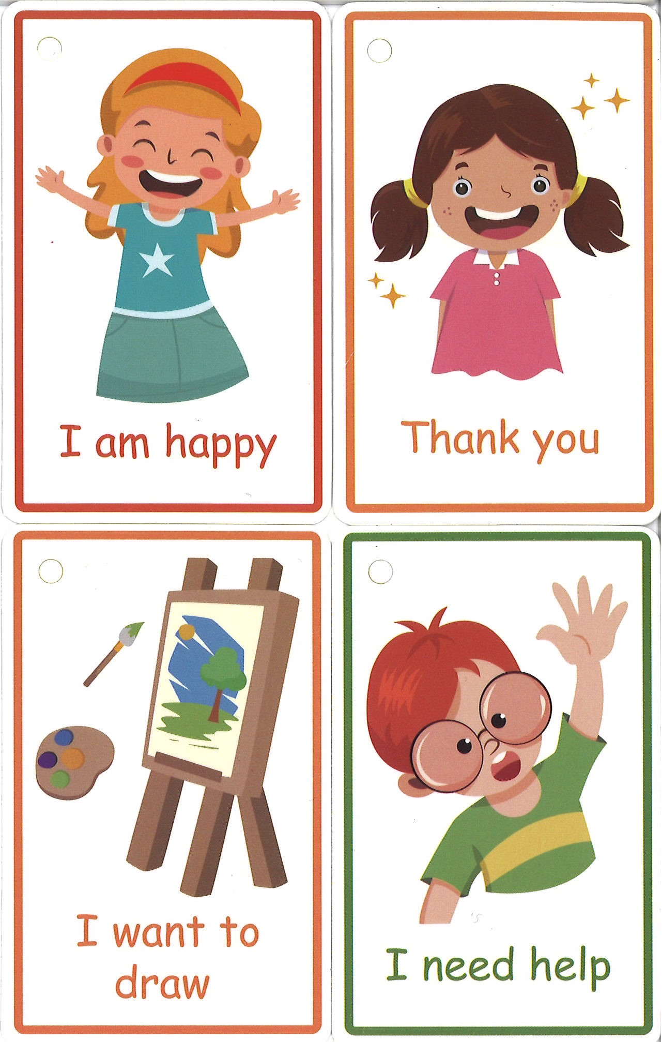

Sensory Space
The Sensory Space will be open and available to anyone who may need it all day. It will be located near the back of the garden. Event Assistants will be on hand to help those who may need it. There will be various sensory support items and different things to do.
To find the sensory space, look out for the Mae Murray Foundation logo on banners and on people’s clothing, like the picture below:

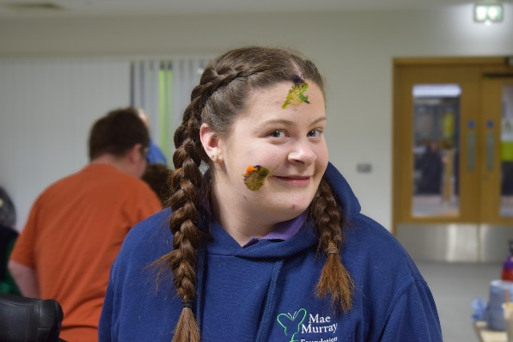

Toilets
There will be toilets including a mobile Changing Place at the back of the garden. You can look for the Changing Place sign or ask an Event Assistant to guide you.


