Inclusive Circus Workshops with Streetwise Community Circus

Pre-booking is required to stop you having to queue for long times.
The Inclusive Circus workshops will be 50 minutes each and are scheduled at 4pm and 5pm each day. They will be located in the workshop tent. There will be step-free access to the tent. Event Assistants will be on hand to help those who may need it, they will be wearing blue hi-visibility vests that look like this:

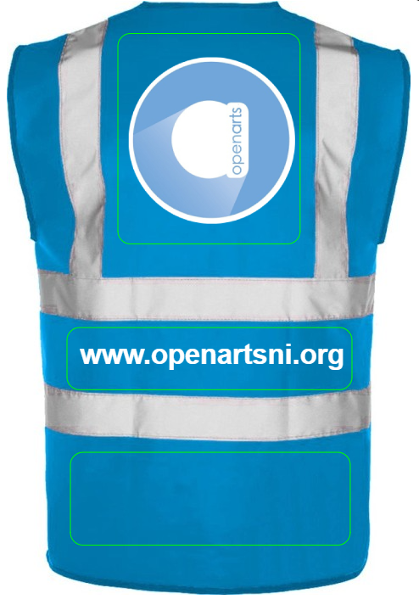

You will meet the friendly circus facilitators from Streetwise Community Circus like Michael in the picture below:
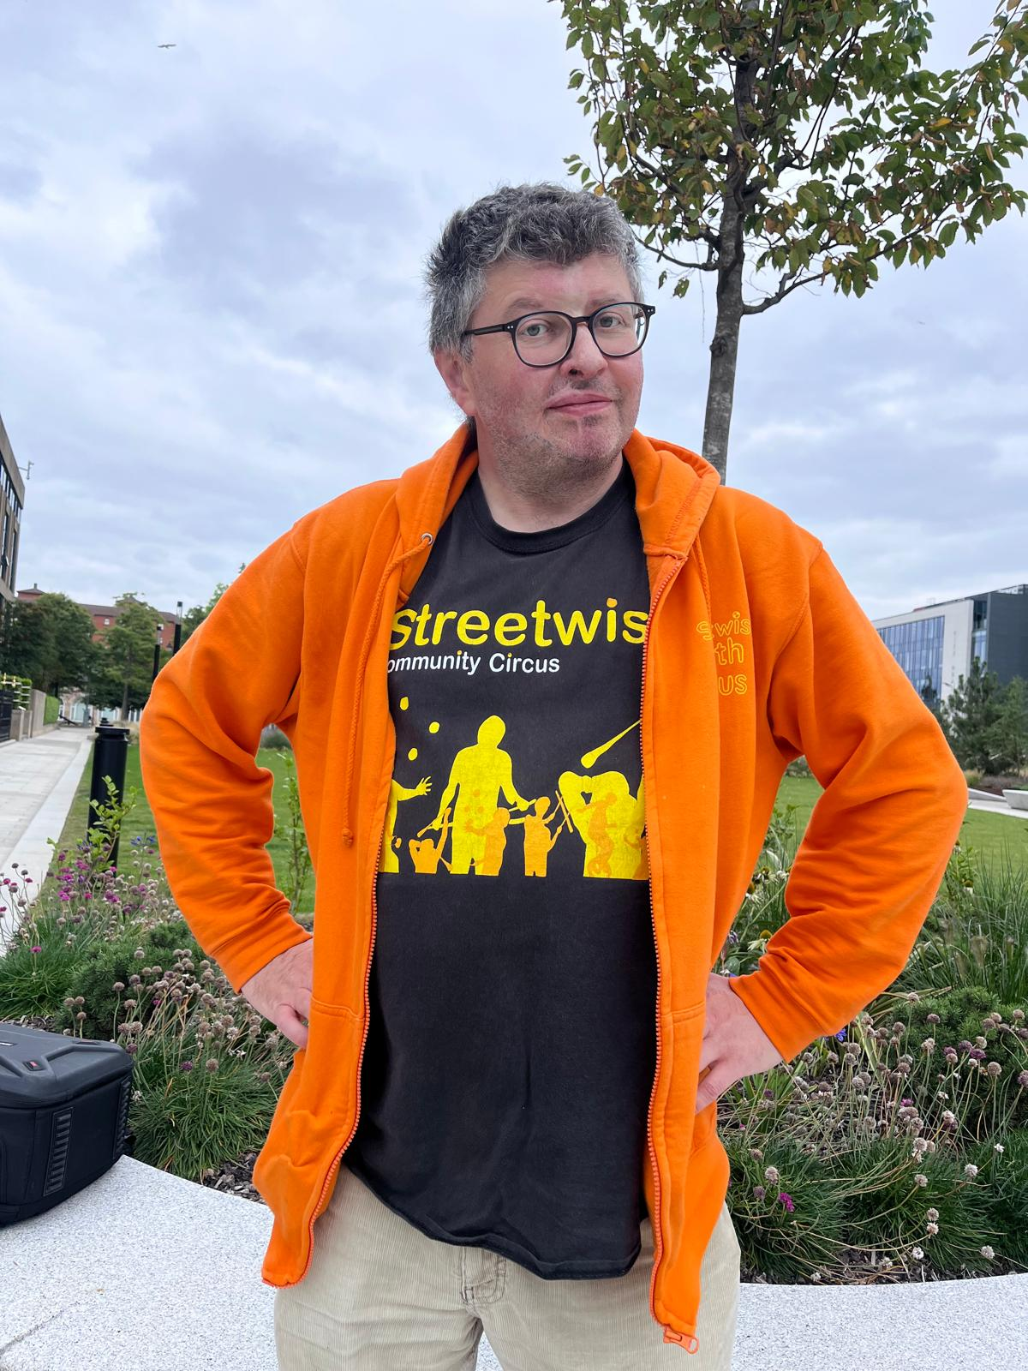

The tent will be a nut free area so you will see signs like this:


