Inclusive Dance Workshops with Talia McDowell Dance

Pre-booking is required to stop you having to queue for long times.
Our Inclusive Dance workshops will be 50 minutes each and are scheduled at 2pm and 3pm each day. They will be located in the workshop tent.
There will be step-free access to the tent. Event Assistants will be on hand to help those who may need it, they will be wearing blue hi-visibility vests that look like this:

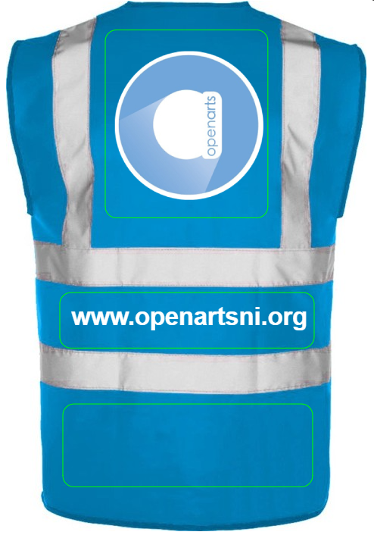

You will meet Talia the dance facilitator, who looks like this:
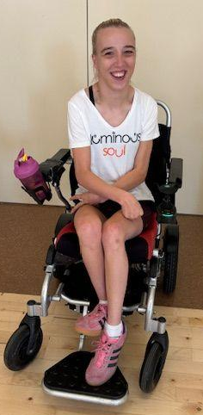

The tent will be a nut free area so you will see signs like this:


