Songs and Gongs

Pre-booking is required to stop you having to queue for long times.
Our Songs and Gongs workshops will be 50 minutes each and are scheduled at 2pm, 3pm, 4pm and 5pm each day. They will be located in a tent.
There will be step-free access to the tent. Event Assistants will be on hand to help those who may need it, they will be wearing blue hi-visibility vests that look like this:

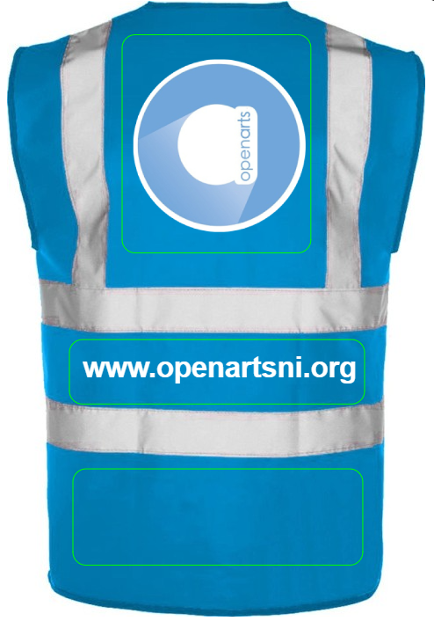

You will meet our facilitators Bev and Jonny, who look like this:

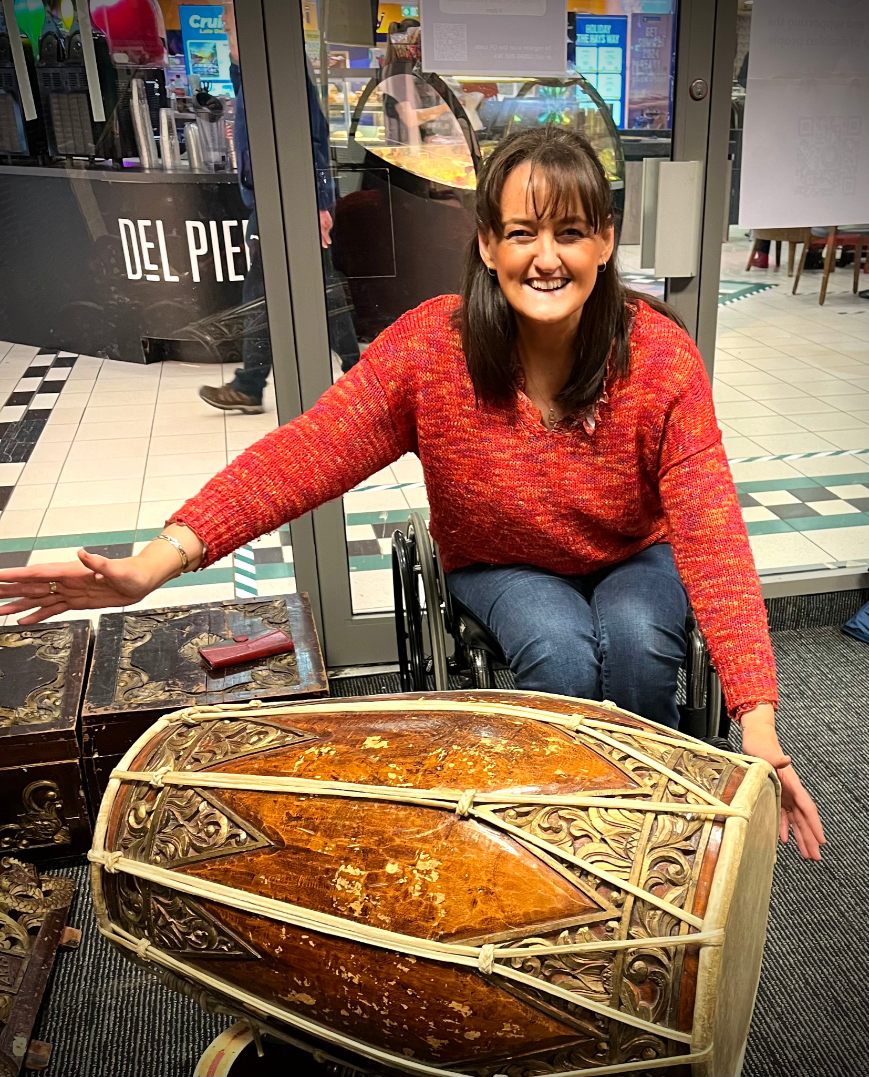
Bev Jonny

The tent will be a nut free area so you will see signs like this:


