Takeaway Theatre

Pre-booking is required to stop you having to queue for long times.
Our Takeaway Theatre sessions will be 50 minutes each and are scheduled at 11am, 12pm and 1pm each day. They will be located in a tent.
There will be step-free access to the tent. Event Assistants will be on hand to help those who may need it, they will be wearing blue hi-visibility vests that look like this:

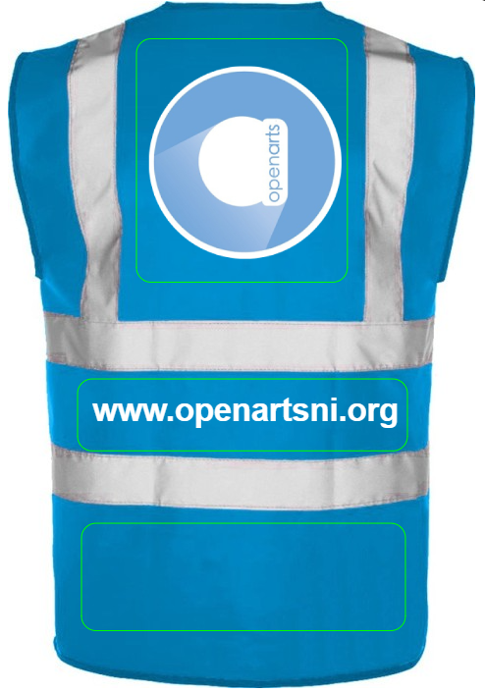

You will meet the friendly Takeaway Theatre facilitators like Stephanie in the picture below:
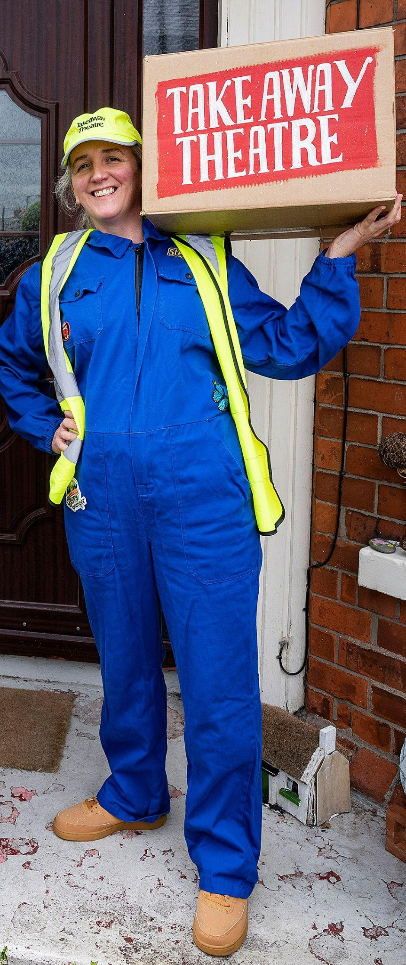
The tent will be a nut free area so you will see signs like this:


